silvaco lab

Experiment: 2

Simulation of Bipolar Junction Transistor

Sounak Mandal

19EC10088

**a. Explain Gummel plot (β vs VBE) for the Bipolar Junction Transistor.**

**Gummel plot of npn Bipolar Junction Transistor**

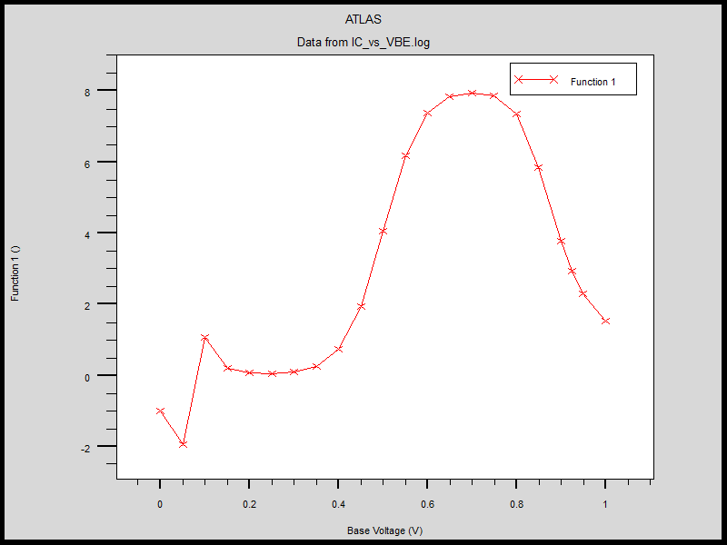

The Gummel plot clearly shows that while we generally assume that the common emitter current gain $β$ is constant, in truth it is varies quite a lot with applied voltage.

1. In the middle flat region, both base and collector current are proportional and the current gain remains constant.
$$I_{C}∝e^{\frac{V_{BE}}{V_{T}}} and I_{B}∝e^{\frac{V_{BE}}{V_{T}}} hence β=constant$$

2. In the low voltage regime, the base current is low and hence generation recombination plays a significant role decaying the base current. The collector current is given by the same formula and hence the overall current gain starts to increase at low voltages.
$$I_{C}∝e^{\frac{V_{BE}}{V_{T}}} and I_{B}∝e^{\frac{V_{BE}}{{ηV}_{T}}} hence β∝I_{C}^{1-\frac{1}{η}}$$

3. In the high voltage regime, high level injection degrades the collector current. But since emitter is highly doped the base current remains unaffected and is given by the same formula. The overall current gain again reduces.

$$I_{C}∝e^{\frac{V_{BE}}{2V_{T}}} and I_{B}∝e^{\frac{V_{BE}}{V_{T}}} hence β∝I_{C}^{-1}$$

It is easier to interpret the Gummel plot if we also plot the base and collector current together in log scale and relate it to the Gummel plot and visualise the three regions and the current relations in these regions.

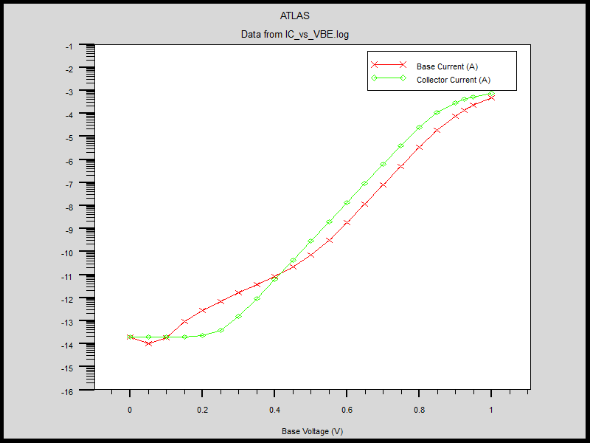

**b. What are the consequences of increasing base doping concentration? Is there any Trade-off between early voltage and β of the transistor?**

1. **Band structure**

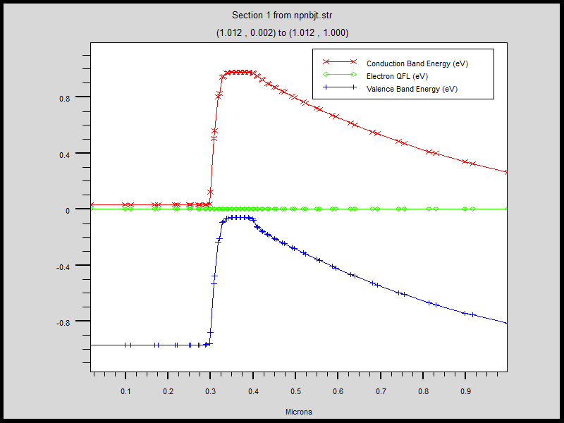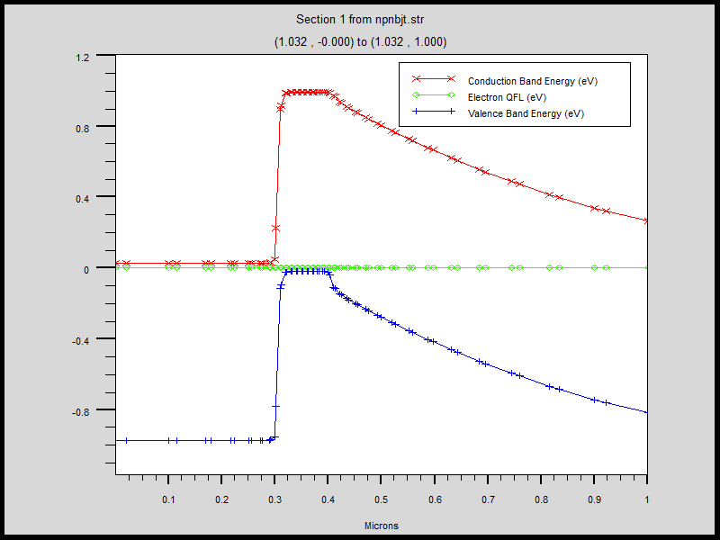

The increase in base doping is clearly depicted in the band diagram. The position of the Fermi level changes with respect to the valence band in base. With increase in base doping, it comes closer to the valence band.

1. **Electric Field**

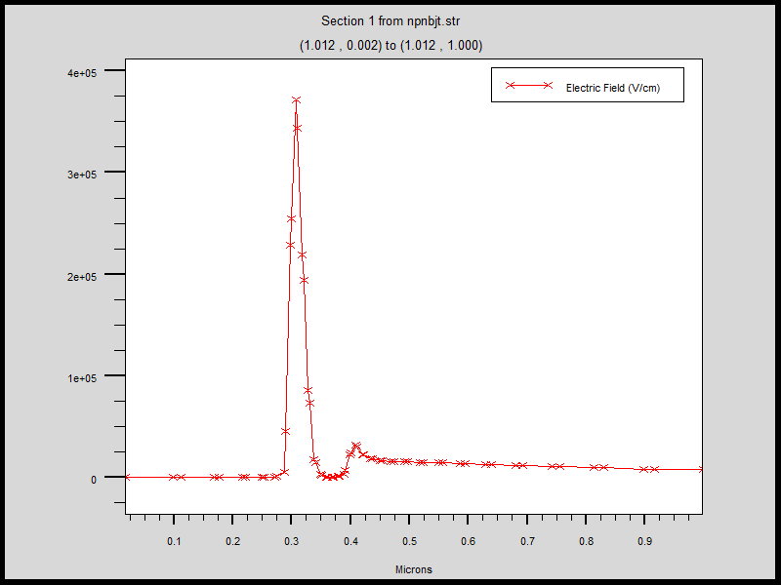 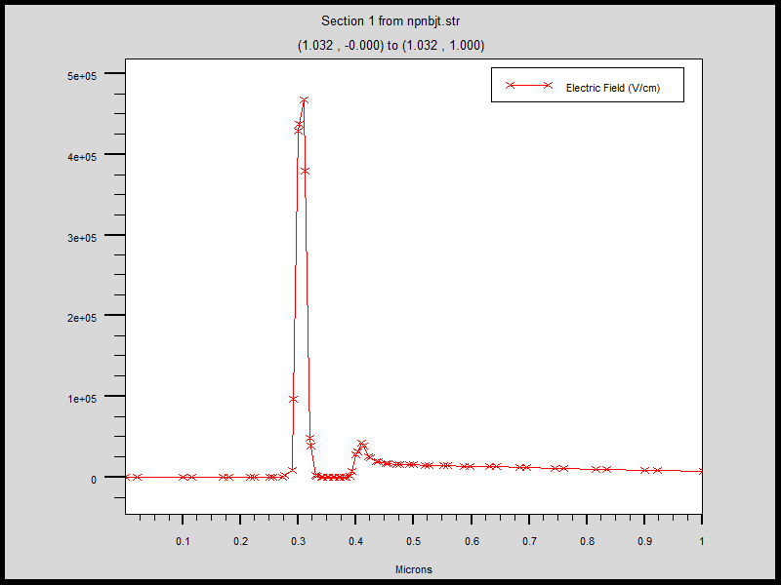

With increase in base doping the maximum electric field in the emitter base depletion region increases. There is little difference in the electric field in the depletion region between base and collector since it was already small.

1. **Early Voltage**

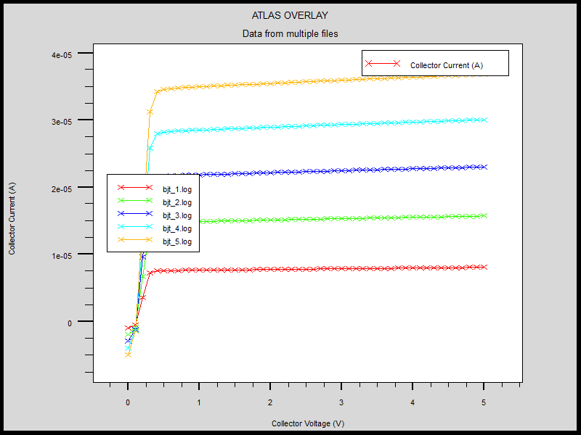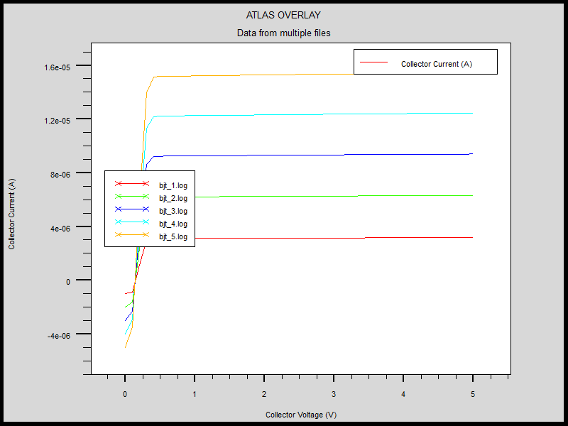

The Early voltage was measured for the two different doping levels using the ruler. It is clear that early voltage increases significantly from the fact that the in active region the curves are much flatter if doping is increased. This can be attributed to the fact that more of the depletion width moves towards collector and the base width modulation becomes negligible.

1. **Current gain**

 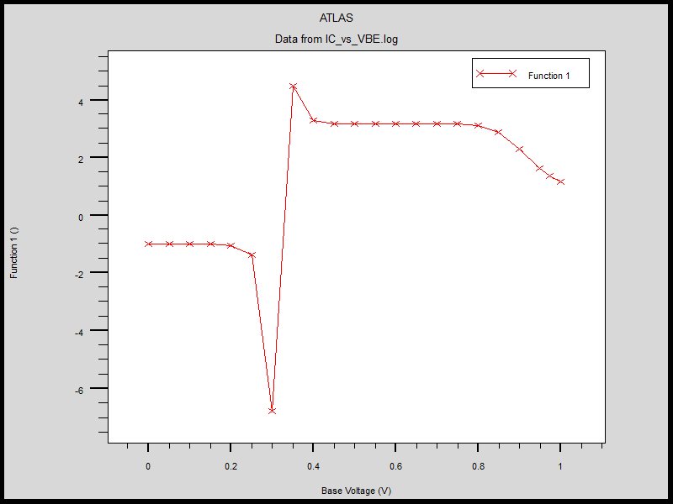

With increase in base doping the current gain remains constant over considerably longer voltage range but the maximum gain decreases. The fall off on the higher side is also not that steep. The erratic behaviour on the lower voltage side is due to the fact that small currents flow and their exact expression are hard to predict.

|  |  |  |
| --- | --- | --- |
|  | Base doping (1e18) | Base doping (5e18) |
| Maximum E field (V/cm) | $$3.75*10^5$$ | $$4.75*10^5$$ |
| Early Voltage (V) | $$80$$ | $$240$$ |
| Maximum β | $$8$$ | $$4.25$$ |

The results show that increasing Early voltage comes at the cost of reducing the β of the transistor.

**c. Plot the band diagram of a PNP Bipolar junction transistor considering the same doping concentrations of collector, base and emitter as given in the code.**

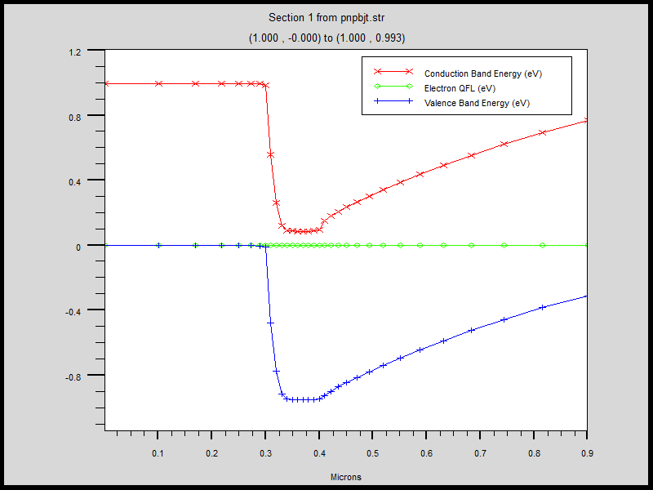

The salient features of the band diagram are:

1. The emitter p-type doping of 1019 cm-3 is so high that the fermi level is very close to the valence band on the valence band.
2. The base n-type doping is also high, though not as high as the emitter. As a result, the fermi level is close to the conduction band but the gap is larger as compared to the emitter region.
3. The collector doping is quite low. The depletion layer extends deep into collector and the bands bend slowly over the entire depletion region. The steep band bending in base emitter junction is not seen in base collector junction.

Summary

1. The Gummel plot is the prediction of a charge control model of bjt called the Gummel poon model. Calculating the slope for higher and lower voltage roll-offs, one can estimate the ideality factor of IV characteristics.
2. The simulation was also done for 1e19 of base doping. However, since here the base and emitter doping are same, the gain is so small that the transistor action is almost absent. The results are below.

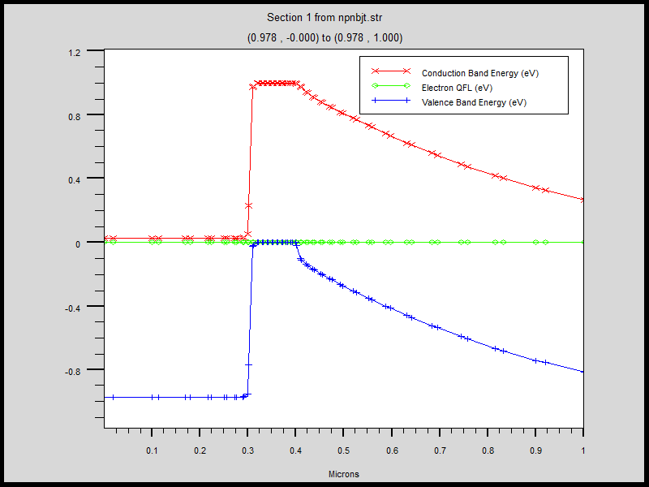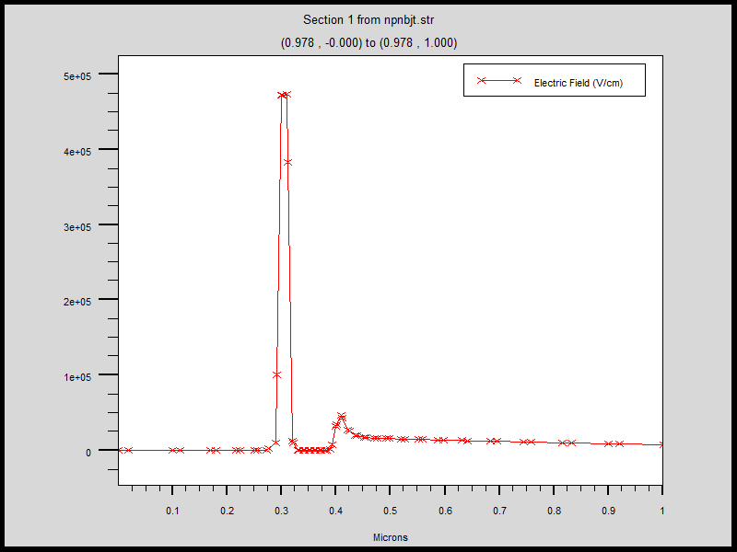

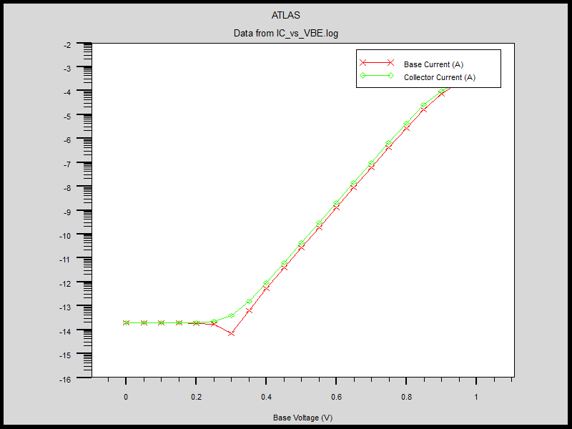

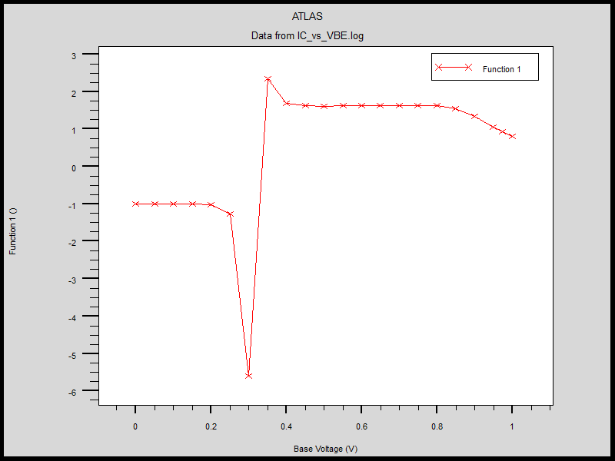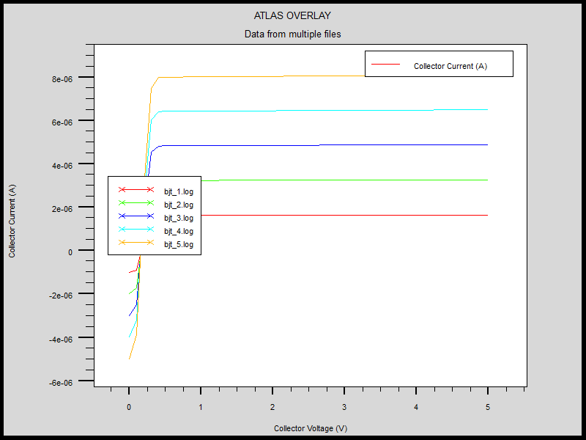

1. The emitter must be much highly doped than base. The emitter doping can’t be made arbitrarily high as conductivity suffers at very high doping. The base doping can’t be made arbitrarily low since it must still be greater than collector doping and low doping corresponds to high resistance. A solution is heterojunction where electrons and holes see different potential barriers and hence the requirement of high difference in doping is not required.
2. The collector generally has graded doping. The doping is much lower near the base collector junction so that most of the depletion region extends to collector. However, it must be increased significantly away from junction so that the collector doesn’t exhibit high resistance.